IAM Assignment

Create I am Admin Group  
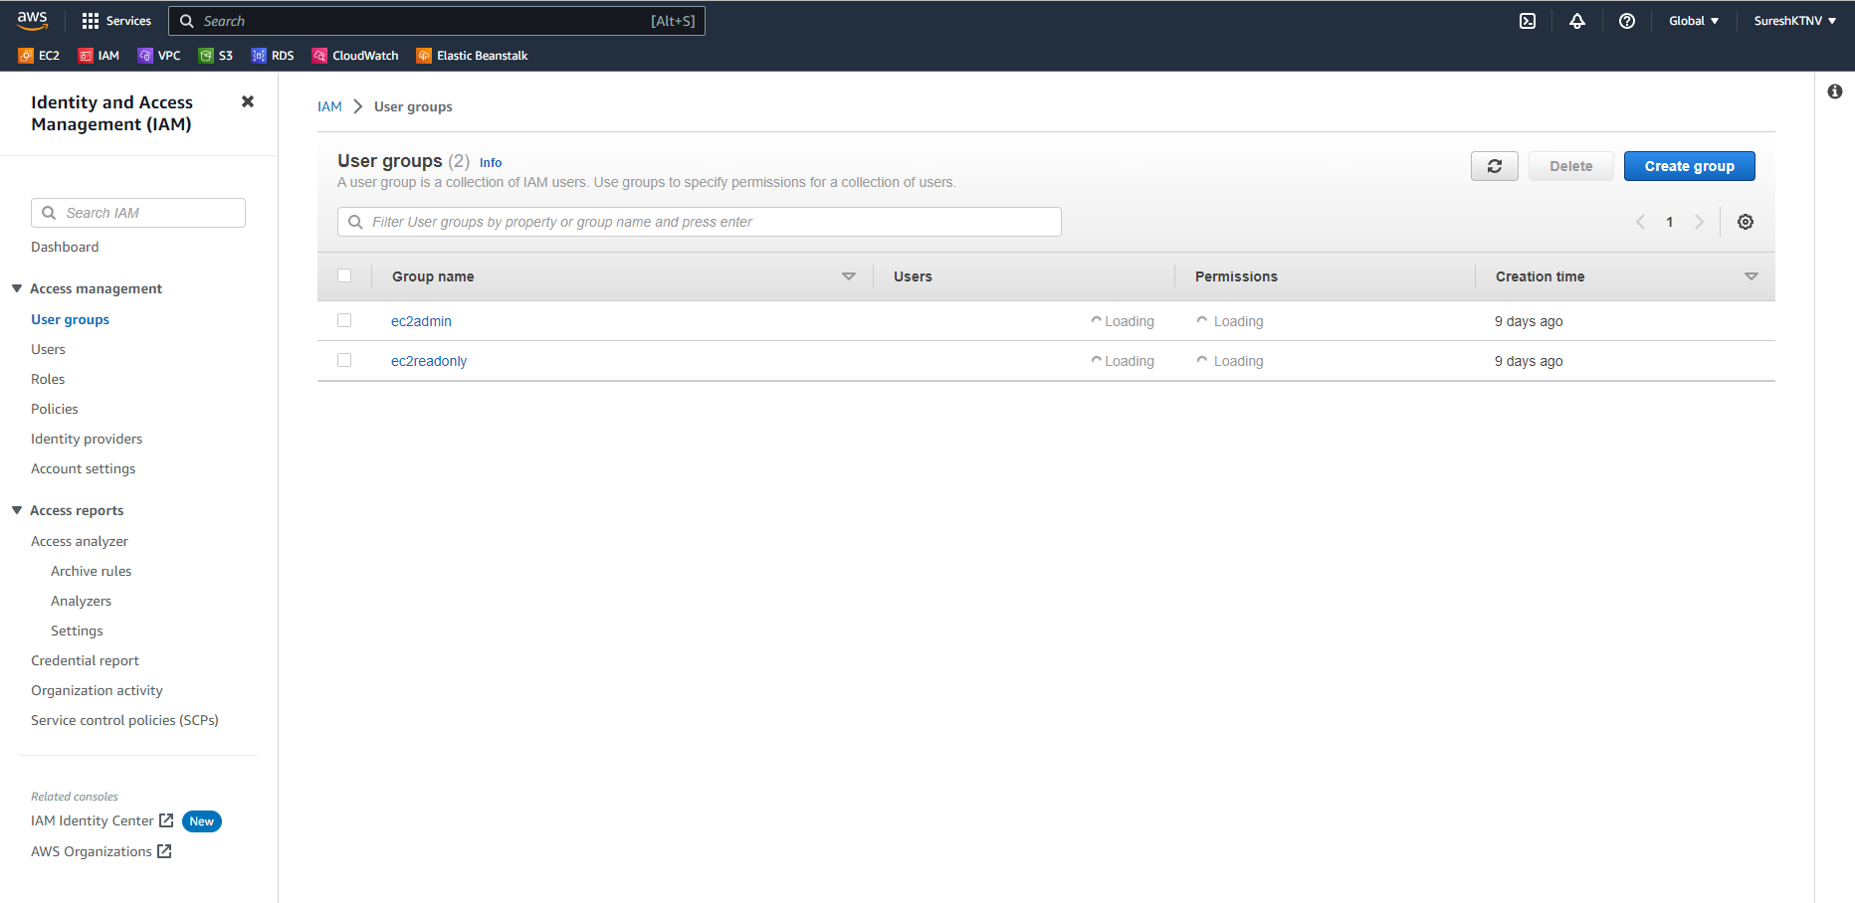

Create Admin user under Admin Group

Create Instance with Adminuser

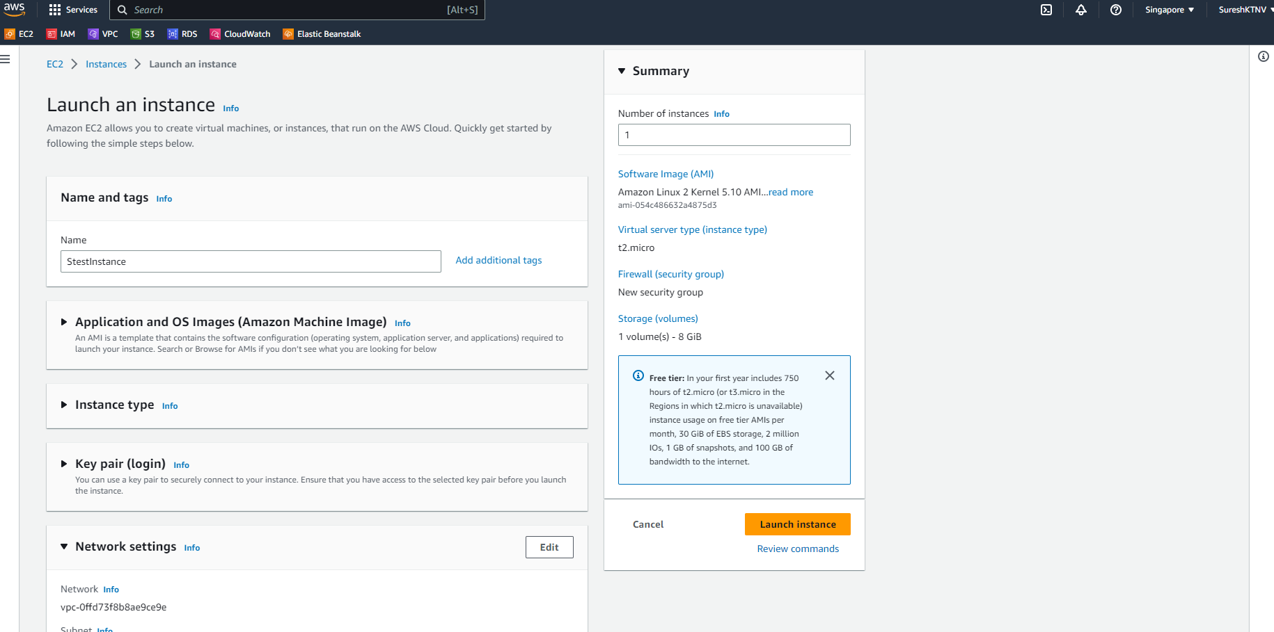

EBS Volume settings:  
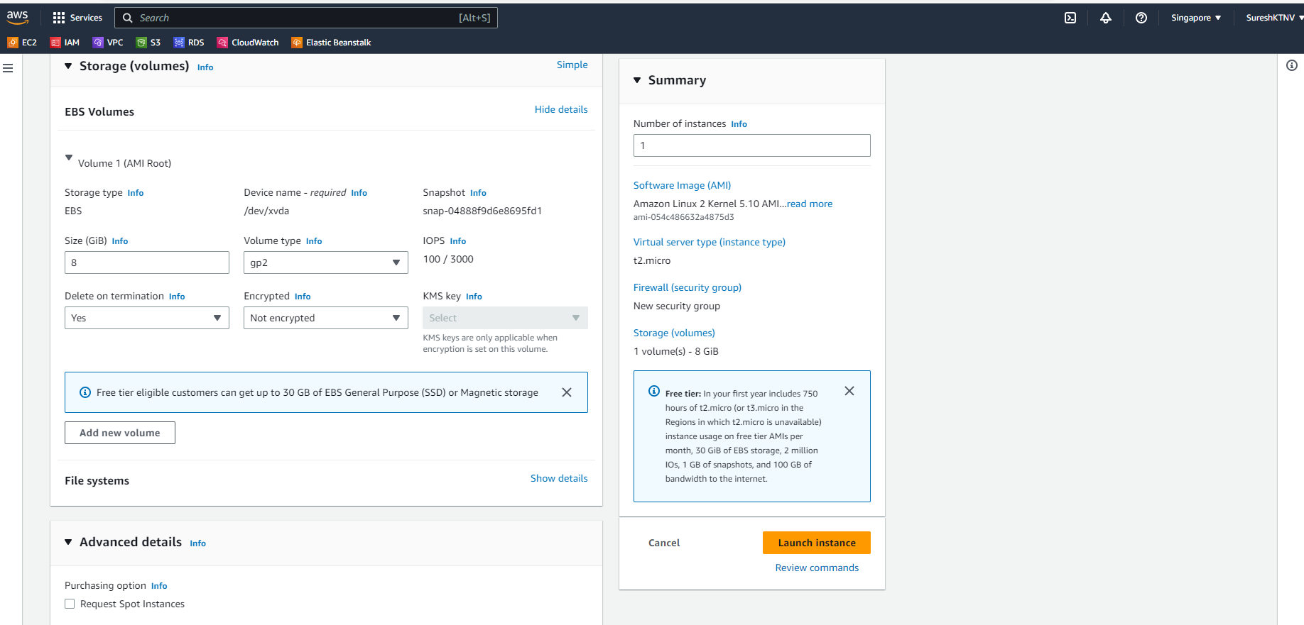  
  
Instance Created (AdminuserEC2Instance)  
EBS Volume Details:  
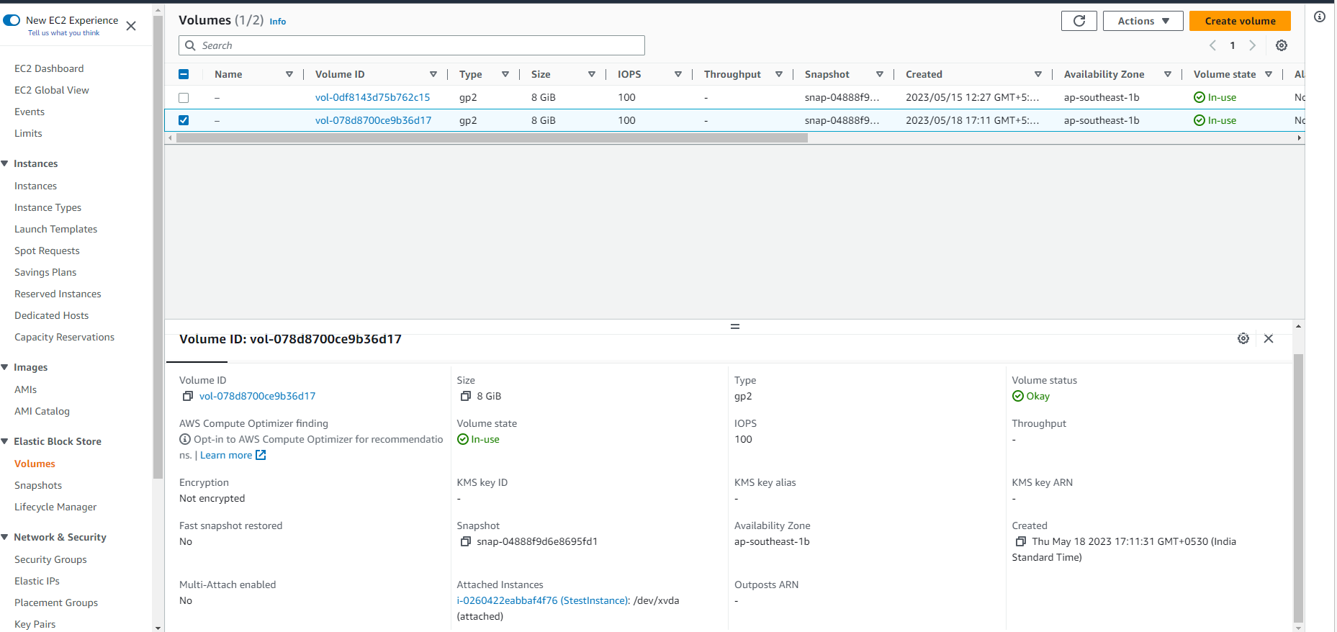  
Terminating AdminuserEc2Instance  
EBS Volume Post Terminating EC2 Instance:   
